Not all wins are equal: measuring team success in ice hockey
The very first step of understanding team performance is to measure and decompose a team’s success. Whether it is top-down approach (e.g. overall team performance) or bottom-up (e.g. player performances aggregated to team-level), a holistic and fair evaluation is important to evaluate each team.
My two cents from this analysis,
Some measures are better for micro-level metrics, like player performances, not macro-level measurements like team success,
When measuring success, Nash-like performance and efficiency of own and others both has to be accounted for an unbiased evaluations
The notes below introduce commonly used measurements derived from on-ice production. Then I showcase how to incorporate the relative performance with a help of a computation to decompose team performance measurements.

What measurements traditionally explained team performance?
What is fair?
When measuring a relative performance (or evaluation in economics), the concept of ceteris paribus becomes very important — controlling all else equal.
I start with two very common measures, Corsi and Fenwick, both intended to capture relative shot productions,
Shot production measures relative difference between shots made for and against
The difference between the two is that Corsi includes missed shots whereas Fenwick includes blocked shots. In layman’s term, the distinction attempts to account for open scoring opportunities regardless of how challenging situations are (or how quality of the opportunities are) vs. any defensive efforts by the opponents, respectively. This article briefly covers the spirit and contrast the two measures.
In-line with the spirit, using a measure of goal score for/against is a widely used metric across sports (especially in soccer, baseball, and cricket): Pythagorean Expectation (PE).
Win percentage is proportional to the relative goal differential for/against
My tableau dashboard plots historical Pythagorean Expectation. This goal differential measure overall well captures a team success. But that is just it — overall trended success.
Going back to the measure of fairness …
It is extremely challenging to measure team performance in National Hockey League (NHL) because some teams have very different playing styles, skill gaps. All the while scheduling is divided up based on conferences and divisions. Any data-driven insight faces challenges of heterogeneity over cross-section and over time: over the course of a long season (82 games over seven months).
As the figure below hints, team’s performance and expectation evolve as season progresses. The realized team success measure does not ‘stabilize’ until the end of season. Moreover, it will be different from historical trend. For example, in 2021–2022 season, we saw less goal differentials to separate teams (steeper curve): Less parity in team performances dictated the ’21 — ’22 season.
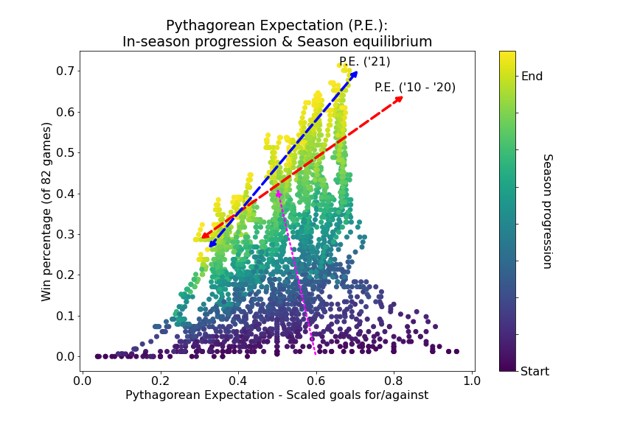Pythagorean Expectation with equilibrium (Calculation by Justin L.)
Because some teams over-do with the scoring productions (especially those teams that are offense-focused like Washington Capitals in 2010’s and ‘20s), these measures can bias how good the team is. Then, are these metrics useless in evaluating modern hockey?
Is Corsi and Fenwick dead?

How did you fare against the opponents’ opponents?
One concern on these metrics is that they only capture how opponents have performed against the team-of-interest. They do not tell us how strong the opponents were. As mentioned above, the parity and heterogeneity can significantly impact and bias the metrics.
More common in college hockey, the measure of Pairwise and Ratings Percentage Index (RPI) attempts to overcome the caveats by measuring the team’s success condition on opponents’ strength of schedule and record. While computationally complex, once the logics are determined, those metrics can be a robust measure and signal of team’s success.(1)
As shown by the code below, I measure the Pairwise and RPI by observing head-to-head records and strengths of records,
How many teams have you beaten more than half of the games played, against teams that have seen with common opponents?
Overlaying this information would provide a Nash-type team ranking, where the parity across each team’s performance can be further distinguishable.
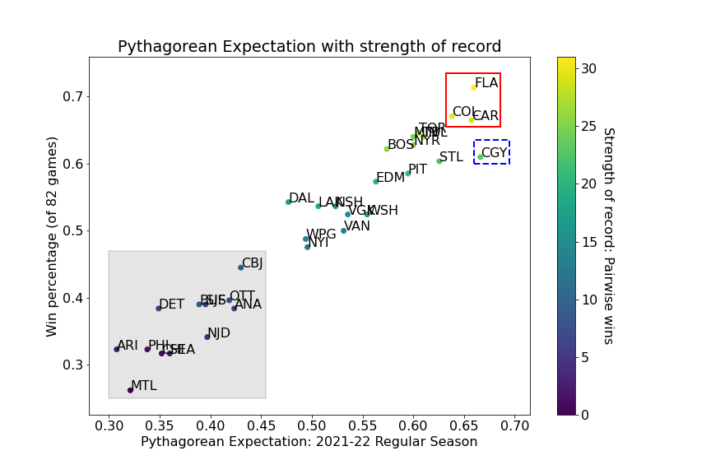Pythagorean Expectation with Pairwise strength of record (Calculation by Justin L.)
The plot shows, for example, that Calgary Flames (CGY) is projected to perform the best (along with Florida Panthers (FLA), Colorado Avalanche (COL), and Carolina Hurricanes (CAR). However, the season win percentage just hovers along with the second tier blocks of teams. One reasoning behind it would be the strength of record, where CGY does not rank higher than the second tier blocks.
Beyond the last-tier blocks of teams (teams in shaded grey area), the parity among teams would be harder to decompose without overlaying the opponent’s relative performance.

Who performed as expected?
Win percentage of the season and final rank across the league (total win points mounts to an award — Presidents’ Trophy) is used to gauge the team’s ultimate season success.(2) I scale and normalize the measures and rank to compare across the metrics. If those measures are not ‘biased,’ I expect to see a one-to-one relative team ranks across the metrics.
Overall, the Pairwise and RPI does a good job correlating with the team’s seasonal performance. Accounting for opponent’s relative performance is important in evaluating of own.
The first two groupings in the chart below showcase shows where Corsi and Fenwick (abbreviated CF) misses marks in team performance. The left panel shows where CF overestimated team production and thus performance. For example, for 2021–2022 seasons, Boston Bruins (BOS) and Calgary Flames (CGY) are ranked as one of the most efficient team by CF. However, observing Pairwise and RPI, it shows that they have not fared well against stronger opponents. High CF thus means that those two teams are generally high-octane/offense team but struggles through stronger opponents.
In reverse, the right panel shows the opposite, where CF underestimated the overall team performance: from St. Louis Blues (STL) to the eventual Stanley Cup (playoff) champion Colorado Avalanche (COL). This further emphasize that incorporating the relative strength is important. Corsi and Fenwick has not been kind to these teams.
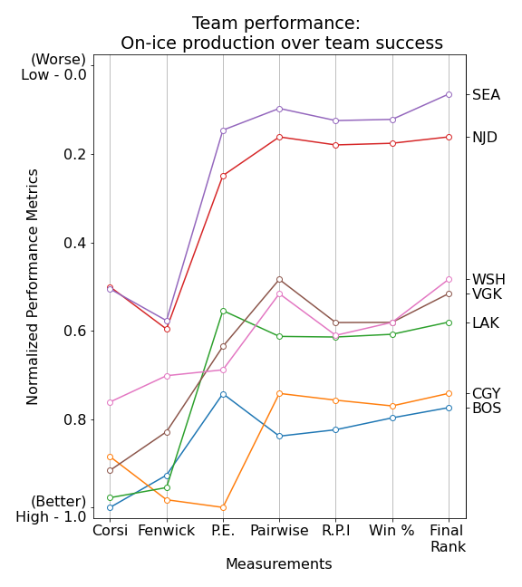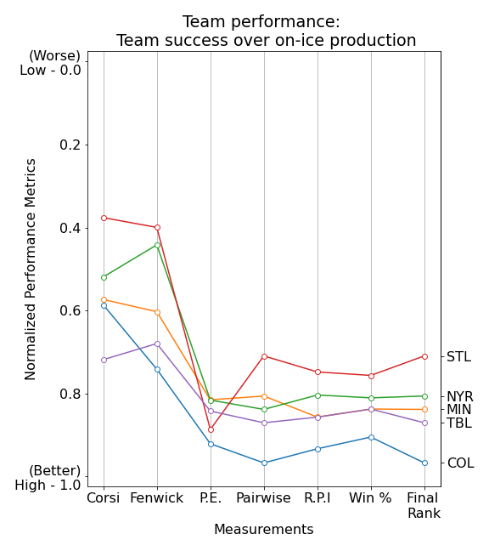When on-ice productions do not capture the realized team productions (Calculation by Justin L.)
For other teams, they may look consistent (the left and right most figure in the panel below). The left panel shows teams suffered through low performing season due to better competitions, whereas the right panel shows as-expected team performance on-ice and overall season.
For some, I observe high production (high CF measures) but see low own and relative metrics (PE to Pairwise and RPI). Simply put, they faced tough opponents and have not had successful seasons because of the strength of schedule.
From the chart in the middle, Pittsburgh Penguins (PIT) is a perfect example, where the competitive on-ice production (relatively high CF) is masked with lack of success against stronger opponent (relatively low Pairwise) — resulting in overall lower team season production.
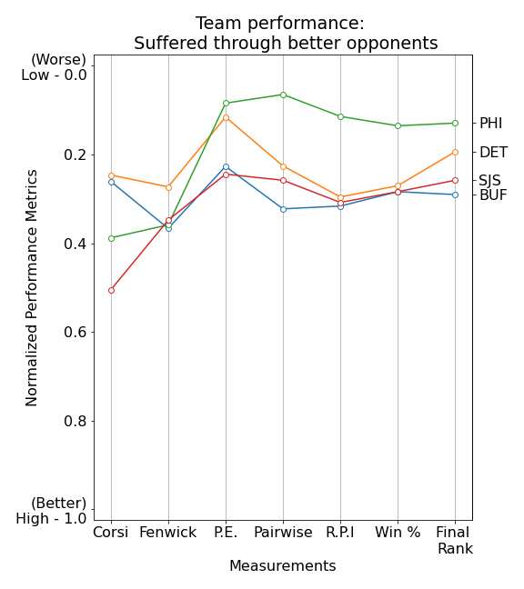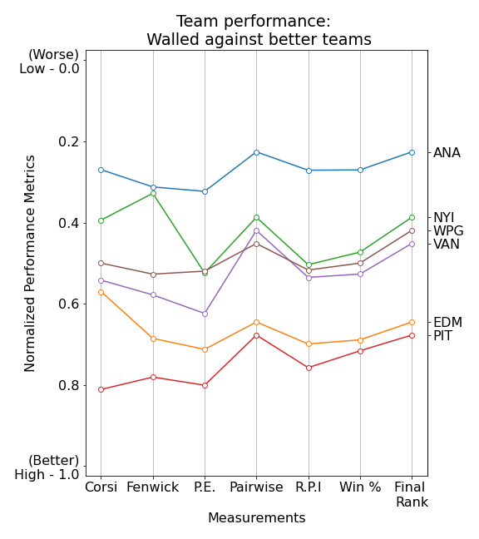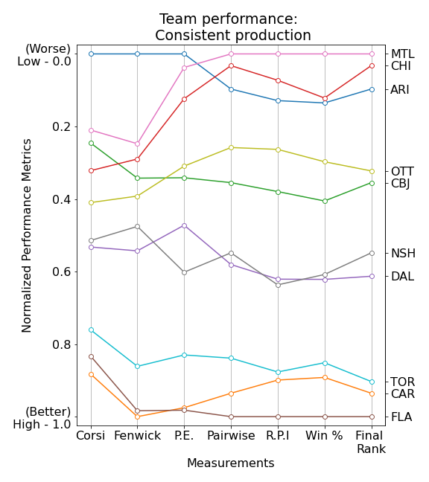When team performance are (not) impacted by opponents’ strengths (Calculation by Justin L.)

Is Corsi and Fenwick dead? No — its not their fault.
I go back to the intro, discussing what is good for top-down approach vs. bottom-up. Ultimately, what’s good for measuring one does not translate to measuring the other —the scope matters.
The performance and production that Corsi and Fenwick attempts to capture is better suited for measuring micro-level activities, like player performances and productions. They may not be the best for team performance - or at least, should not be sole metrics to measure or benchmark team success. One should not go overboard with Corsi and Fenwick — not because those metrics are weak, but because those metrics are not intended to be overused and the caveats well aware and reminded by audience of technical or non-technical audience.
Even then, accounting for opponent’s efficiency is crucial to successfully measure own efficiency and production. The calculation, while computationally challenging, would allow us to decompose team’s success by pointing out the production by the level of competition.
Echoing the economists’ battle cry -
Identification, identification, and identification!

The full scope of code and analysis is saved in my repository.
(1) The main issue with college hockey is that those ranks are predetermined before the season starts, and progressions are made by continuous voting during the season. This implies that the rankings more times than not is under a risk of self-fulfilling bias.
(2) One can use playoff performance and eventual Stanley Cup win as another success measure, which I plan to evaluate on a later date.

Measurement Calculations: Basic

Measurement Calculations: Head-to-head

